Project Proposal / System Study Report

Course Name: System Analysis and Design
CourseID: CSE307
Section: 02
Course Instructor: Dr. Razib Hayat Khan
Submission Date: 06/06/2026

Title: Volunteer Emergency Response Alliance (VERA)
A platform that connects people in need with volunteers, donors, NGOs, hospitals, emergency responders, and relief organizations through a centralized emergency assistance network.
ID: | Name: | Contribution%
2311960 | Md. Mahmudul Hasan | 100%
2310604 | Ridwan Hasan Khandakar | 100%
2022752 | Kazi Fatema Tuj Johra | 100%
2312226 | Fouzia Abida | 100%
2310690 | Syed Mehedi Hussain | 100%
2210892 | Sowhardra Paul | 100%

VERA – Volunteer Emergency Response Alliance

1. Project Goal
VERA - Volunteer Emergency response alliance is an information system that centralises emergency assistance and resource coordination in times of need. It connects people in need with people that can help like volunteers, donors, hospitals, bloodbanks, NGOs, humanitarian organisations, emergency responders, and relief organisations. Furthermore, the system is very helpful in disaster scenarios, where connecting and coordination with organisations are fragmented and inefficient. Teams can move faster with connected communication and cover as many areas as possible.

This system will improve the speed, efficiency, transparency, communication, coordination, and reliability of emergency assistance. This system will work like an unified platform for coordinating and requesting volunteers as well as managing resources when handling disaster response operations. People can also report emergencies, organisations can request support which can lead to a coordinated and effective outcome. VERA bridges the gap between a person who is in need of help and capable and experienced volunteers, organisations who can provide assistance.

1.2 Project Objective
● To establish a common ground for emergency services and resource coordination
● To connect individuals who require assistance to volunteers, donors, NGOs, hospitals, blood banks and other emergency services organizations
● To minimize response time in case of medical emergencies, natural catastrophes or humanitarian crises
● To facilitate blood donations from donors to recipients
● To organize transparent fund raising and donation campaigns during emergency response activities
● To track the locations of emergency services requests, volunteers, and aid work effectively
● To assist organizations in recruiting and coordinating volunteer actions via a common platform
● To create volunteering and certificate programs that motivate students to participate in social initiatives
● To enhance coordination and information exchange among all participants in emergencies
● To assure transparency and reliability of emergency response and resource allocation processes

2. History Leading to Project Request
Bangladesh ranks as one of the highly populated nations in the world. There are numerous emergencies that occur within this nation such as road traffic accidents, medical emergencies, floods, storms, fires and others. Everyone needs assistance, whether it's the need of blood donation, emergency transport, ambulance facilities, food, shelter and rescue services. Unfortunately, at present, there isn't any single platform which connects all those in need of help with people who can give them their help. Time is being wasted while the situation demands prompt reaction from the side of people.
At present, people use Facebook groups, personal calls, Messenger or WhatsApp to spread information about their request. Of course, sometimes it can be helpful but it takes lots of time and it's quite inefficient and disorganized process. People usually waste their valuable time searching for a volunteer, blood donor or hospital while the matter requires prompt reaction. Furthermore, fund raising activities connected with medical emergencies or natural disasters are quite inefficient and not organized enough.
During large scale emergencies like floods, cyclones, fire and earthquakes, the problem gets even worse since different organizations, volunteers, hospitals, blood banks and relief teams act in an uncoordinated manner. In most cases, some locations get too much support while others may go totally unassisted due to lack of coordination among various agencies involved. Field volunteers find it difficult to coordinate with incoming teams on which locations have been assisted and which are yet to be assisted. There will be no proper tracking system to guide the movement of resources in order to reach vulnerable groups efficiently and quickly.
As a solution to the above problem, I would propose a centralized emergency assistance and resource coordination system known as VERA (Volunteer Emergency Response Alliance). This system will bring together various stakeholders including citizens, volunteers, donors, hospitals, NGOs, blood banks and emergency relief teams. Through this centralized system, there will be proper tracking of emergency and relief operations in terms of specific location in order to determine which locations are under-served and require assistance. The system will also be a fundraising portal where people can raise money and resources for emergency purposes.
Furthermore, VERA would serve as the central platform for the recruitment of volunteers by the NGOs and other humanitarian bodies. The recruitment process for volunteers, management of upcoming programs, and the overall management of the activities of the volunteers can be done using VERA. There are many students who search for volunteer opportunities to gain hands-on experience and to make themselves valuable for society. Moreover, they would like to get certificates as a mark of recognition for the same which would boost up their career profile. Presently, the available data regarding volunteer opportunities is available on different social networking sites and personal connections thus, it becomes very tough for the students to find out such information.

3. Problem Identification, Issues, Concerns and Opportunities

3.1 Problems
- Emergency Response Is Slow: When people need help really fast they use social media platforms or Ask their friends and relatives. This makes it hard to get help quickly when it is really important. It causes delays.

- Nobody Is In Charge: Volunteers, hospitals, blood banks and people who want to help do their thing. They do not work together because there is no one place where they can all connect. This means help is not given in the way.

- Difficulty Finding Blood Donors Quickly: Patients and families often struggle to locate suitable blood donors during medical emergencies.

- Help Is Not Used Well:Information about people who need help is everywhere. Sometimes the same person gets help twice while someone who really needs it does not get any help. This is not a use of the help that is available.

3.2 Issues
- People Cannot Connect: It is impossible for those who want to help and those who need it to locate each other. As a result, people find it more difficult to obtain the assistance they require.

- Not Knowing Who To Trust: It's difficult to ensure helpers are who they say they are. This means those who need help may not get it. People want to trust those who help. This shows that those who truly need assistance may not receive it.

- Donations Are Not Transparent: People who give money or things to help don't always know what happens to them. This is the problem because we want to make sure that help is given in a way. Emergency response and help need to be organized so that people can get the help they need quickly and effectively.

3.3 Concerns

Difficulty in Verifying Volunteers: VERA needs to verify the users to create a reliable and secure ecosystem, which takes time.

When a big disaster happens a lot of users join and this can overload the system managers causing delays when help is needed the most. VERA has to verify these volunteers. This is a big challenge.

- Risk of Misinformation: VERA centralizes emergency requests scattered across social media groups, phone calls, and personal networks, which causes delays in reaching help, misinformation, and inefficient use of resources.

Only centralizing the need and resources does not necessarily reduce the risk of fake information. If the system lacks automated text filtering, duplicate detection, or request status updates, it will only increase the probability of false data without solving the problem.

- Fake Requests and Volunteer Security: The system allocates volunteers to participate in emergency requests to rescue, donate blood, or distribute relief in the field.

Fake requests can lead volunteers to dangerous or life-threatening locations. Alongside risking the life of the volunteer’s life, this kind of situation can waste limited resources. At the same time, users will eventually distrust the system.

- Communication Problem During Environmental Disaster: VERA connects the volunteers with the people affected in severe natural disasters like cyclones, floods, and fires.

Unfortunately, our towers and power systems are black out during these disasters. If the system is fully dependent on the internet, it will be a total infrastructure failure at the time it needs the system the most.

- Challenging for Technically Handicapped People: VERA is an information and technology system, and the main users are regular citizens, donors, and victims.

People in the rural are technically challenged, elderly, or individuals who do not have access to smartphones will face serious barriers using the system, and eventually, people in need of the system the most will be left out.

3.4 Opportunities

- Targeted Request and Faster Response: Users can make a specific request rather than a generic one.

For example, someone requests need for B+ blood. Not necessarily, the system will notify everyone. It is possible to write an automated routing algorithm that matches and only alerts the nearest, relevant blood donors and blood banks, significantly reducing the delay in response.

- Ready-to-Deploy User Base: The core idea behind VERA is: "People who need help and people who can help often cannot find each other quickly”.

After a large-scale disaster like cyclones, floods, or earthquakes, a majority of the time is wasted creating a rescue team from scratch. As VERA is also used for everyday emergencies, continuous engagement keeps the volunteers active and familiar with the system, and it slowly builds a widespread, ready-to-deploy volunteer team to beat a sudden disaster strike.

- Nationwide Safety Ecosystem: In the long-term, VERA’s vision is to become a national emergency assistance ecosystem where citizens, volunteers, organizations, hospitals, blood banks, donors, and emergency responders can collaborate and operate on a single system.

VERA breaks the communication gap and centralizes the data. This can help hospitals and emergency services work together smoothly and provide aid quickly. VERA can help make the country a safer place.

- Effective Use of Resources: VERA keeps track of all the donations, including money, food, clothes, medicine and emergency equipment.

Sometimes one area gets much aid while another area gets nothing. VERA can help make sure that the aid is distributed fairly. VERA can help ensure that everyone gets the help they need.

- Expand Globally: While VERA’s vision is to build an emergency assistance network countrywide, the fundamental crisis it is based on is global.

The system’s design represents a huge opportunity to scale internationally. VERA can be adapted by global humanitarian organizations to coordinate cross-border disaster relief and standardize resource management in crisis-prone regions worldwide.

4. Product / Solution Description

4(a). Description of the Solution
The proposed solution is a web-based Emergency Assistance and Resource Coordination Information System. It is designed to centralize critical communications, replacing the fragmented and inefficient networks currently spread across social media and personal messaging apps. By establishing a unified system , it eliminates response delays, filters out misinformation, and ensures resources reach those in need without duplication of effort.
- Users can do : Citizens, patients, and disaster victims can immediately log time sensitive emergency requests. They can generate targeted alerts for urgent blood donations, immediate medical aid, ambulance dispatch, oxygen or medicine supplies, food assistance, temporary housing, and emergency transportation as well as file missing person reports.
- Volunteers can do : After registering an account ,submitting identification and successfully passing the system’s vetting process, verified volunteers gain the authority to accept open requests, join active rescue missions, manage local relief distribution, and actively support blood drives or disaster operations.
- NGOs can do : Humanitarian organizations utilize the platform as a centralized coordination hub. They can monitor active emergency signals, accept assistance requests, mobilize and deploy volunteer teams, manage relief supplies and log completed actions to maintain operational accountability.
- Hospitals can do : Medical centers and blood banks operate as localized response nodes.They can broadcast urgent, location-specific requests for specific blood groups, receive direct system notifications about nearby emergencies, coordinate blood donation networks, and collaborate with volunteers to expedite life saving care.
- Donors can do : Financial and material benefactors can pledge critical resources to the platform, including monetary funding, food, medical supplies, clothing, emergency gear, and relief items. They can also view tracked resource allocations to ensure complete transparency and system accountability. NGOs and humanitarian organizations can publish volunteer chances, recruit volunteers, manage voluntary involvement, and coordinate military volunteer activities through the platform. Certification management formation can issue participation certificates to volunteers upon successful completion of approved volunteering programs. voluntary can maintain a verified record of their volunteering activities and certifications within the system. Fundraising campaign managements like NGOs, relief organizations, and authorized users can create fundraising campaigns for aesculapian emergencies, disaster assuagement, and humanist causes. Donors can contribute through the weapons platform and track the utilization of donated imagination. The system also can monitor emergency response activities through location - ground tracking and identify underserved or unattended tragedy areas. This helps organizations allocate resources efficiently and head off duplication of relief exertion. Lastly, the system can operate through web and mobile platforms and may support location-based emergency services.

4(b). Project Stakeholders
- Citizens
- Volunteers
- Blood Donors
- Hospitals
- Blood Banks
- NGOs
- Emergency Response Teams
- Relief organizations
- Donors
- Government Agencies
- Disaster Management Authorities
- Fire Service and Civil Defense
- System Administrators
- Developers
- Students
- Educational Institutions

4(c). Project Rich Picture
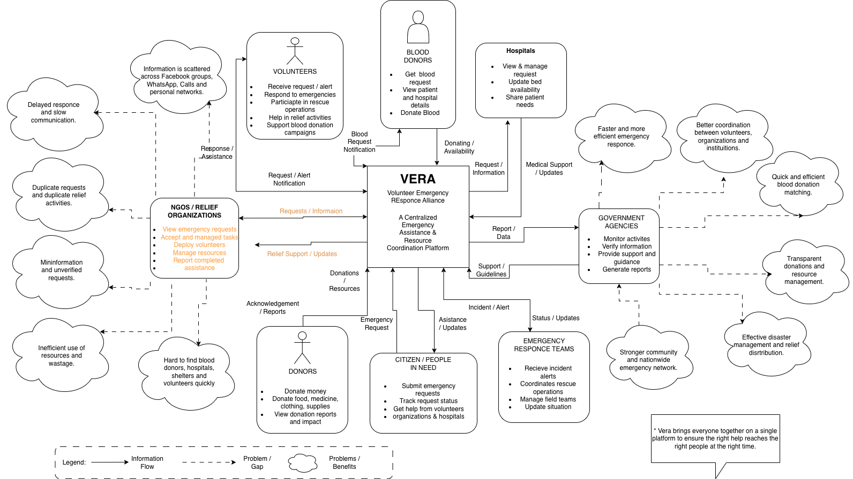
Figure 1. Project Rich Picture

The Rich Picture illustrates how citizens, volunteers, NGOs, hospitals, blood banks, donors and emergency response organizations interact through the VERA platform to provide emergency assistance and coordinate resources.

4(d). Hardware and Software Details

Hardware:
- Cloud Server – system hosting and centralised processing.
- Devices – Desktop/Laptop for administrators and users.
- Router or Network Equipment – Internet connection
- Smartphone – Users, volunteer, field management.
- GPS-enabled Devices – For location tracking and mapping

Software:
- Operating System – Ubuntu server to manage system operations.
- Backend Framework – Django (Python) or Node.js (Express) for server-side development.
- Frontend Framework – React.js for UI development.
- Database – PostgreSQL for secure data storage and management.
- Web Server – Nginx because it is scalable and prevents downtime on upgrade.
- Authentication Service – JWT Authentication for ID authentication.
- Maps Service – Maps API for location based operations.
- Notification Service – SMS and Email Gateway for emergencies.
- Cloud Platform – AWS for cloud server.

4(e). Functional Requirements
- User Registration - Users can create accounts.
- User Authentication - User can securely login and logout.
- Volunteer Verification - Volunteers can submit NID/Passport/Other Identity documents for verification.
- Become a donor - Users can fill a form to become a donor.
- Blood Request Management - Users can create blood requests, flag it (mark as done/not needed anymore).
- Blood Donor Search - System will identify suitable donors and notify them if they signup for donation.
- Emergency Request Submission - Users can create emergency assistance requests.
- Resource Tracking - NGOs can track resources available.
- NGO Coordination - NGO and other organisations can communicate and request support, send volunteers.
- Donation Management - People can donate money and other resources via the system.
- Location-Based Search - Users can search for nearby volunteers, hospitals, blood banks, and resources.
- Notification System - System can send notifications to the stakeholders.
- Shelter Management - System can manage information about available shelter.
- Incident Reporting - Users can report disaster-related/emergency information.
- Request Verification - Authorized users can verify emergency requests.
- Report Generation - Administrators can generate operational and statistical reports if needed.
- Role-Based Access Control - Different users receive permissions according to their roles.
- Volunteer Opportunity Management - NGOs and organizations can publish volunteer opportunities, recruit volunteers, and manage volunteer involution.
- Certificate Management - Organizations can issue, manage, and verify volunteer participation certificates.
- Fundraising Campaign Management - Authorized organizations can create fundraising campaigns, receive donations, and track fund utilization.
- Disaster Coverage Monitoring - The system can track relief operations on a map, identify underserved locations, and notify organizations about areas requiring additional support.

